**///** /Thematic Workshop 1 – OSLO TRAPEZE/

**////////////////////////////////////////////////////////////////////////////////////////////////////////**

**Date**: 23/09/2021

**Time:** 13:00

**Location**: Online – Microsoft Teams Meeting

# Attendees

* Digitaal Vlaanderen
  + Frédéric Hennequin
  + David Van den Brande
  + Lauro Vanderborght
  + Dimi Schepers
  + Michael Geamanu
* Datanutsbedrijf: Filip Borloo
* Datavillage
  + Frederic Lebeau
  + Philippe Ducchesne
* Inrupt
  + Esther De Loof
  + Nick Mondada
* TenForce
  + Alexande Vasylchenko
  + Bert Van Nuffelen
* Doccle: Bram Lerouge
* myCSN: Jan Geukens
* Meeco: Jo Vercammen
* KBC: Nils Meulemans
* Fluvius: Koen Putteman
* Elia: Michiel Verbeeck
* Cipal Schaubroek: Wim Van Acker

# Agenda of the working group

|  |  |
| --- | --- |
| **Part 1** | Welcome |
| **Part 2** | Reason for this trajectory |
| **Part 3** | Summary of the previous workshop |
| **Part 4** | Scoping of core consent |
| **Part 5** | UML – Main concepts |
| **Part 6** | Discussing the draft model |
| **Part 7** | Q&A and next steps |

## Part 1: Welcome

All attendees presented themselves and the input was used to put together the list of attendees.

## Part 2: Reason for this trajectory

Introduction was given on the reasoning behind TRAPEZE and the focus on core consent. Everything is shown in the presentation.

## Part 3: Summary of the previous workshop

A short summary of the previous workshop was given in the presentation. The previous workshop was the business workshop, and the meeting minutes of this workshop are available online.

## Part 4: Scoping of core consent

Here the generic use cases are discussed which were developed based on the previous workshops. The use cases form the basis of the draft model which will be discussed in part 6.

**Use case 1:**

* Frequency/cadence should also be added to the specifications. For example: show wages monthly for the next year. Meaning it should automatically stop after the 12th time.
* Audit trail is important. No room should be left for discussion. The identity of the person that gave consent someone should be undebatable and clearly documented.
* Monetizing data should be something to take in mind during the use case. Hence, it is important to be able to give a number of times consent to a company to access your data. Expiring condition can be more general in this case.
* GConsent has limitations with regards to data provider and datatype. It is important to add the origin of the data to the datamodel.

**Agent vs Datasubject:**

* Agent: person that gives consent.
* Datasubject: person whose data will be shared.
* Use case 1 is not about the delegation of consent, so it is more logical to use *datasubject* instead of *agent*.

**Granting consent vs granting access are in essence different:**

* Consent: giving consent to something concrete.
* Access: access to a dataset.
* Fundamental discussion here is the question if consent is the right word in the light of GDPR, contractual agreements and legal meaning. Filip Borloo of Datanutsbedrijf is currently looking into this.

How do we handle the complexity of consent? For example, you want the granularity of the given consent to change.

## Part 5: UML – Main concepts

A short introduction to UML was given to be sure that everyone can understand the draft model. Is the location relevant in a digital world?

## Part 6: Discussing the draft model

During the workshop we used Mural as a virtual whiteboard. The pictures are given below and link to the Mural is added [HERE](https://app.mural.co/t/beadvtc7549/m/beadvtc7549/1632310480236/577521b34ffa2cfaf955f3e953503eace91786bf?sender=u91199267117038c13b019919).

### Exercise 1: Is there anything missing in the draft model?

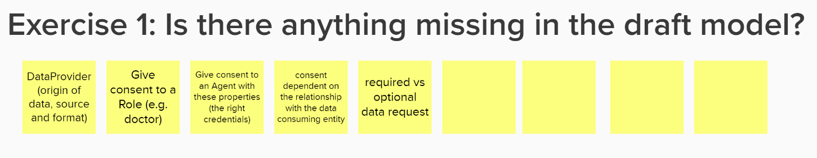

* Credential consents encounters an extra complexity as most authentication systems are bound to the person him/herself. Something that will have to be investigated.
* We want the relationship to be defined. As the nature of the relationship could change someone’s willingness to give consent or not. Purpose is linked to this, but it is not because of a specific purpose that you want to share it with entities with which you have a different relationship.
  + Consent could be a person having a relation with a certain bank. I want to share my wage if I want a loan, not if I just have a bank account. So, it is important that they have access because you want a loan, not because you have a bank account. Someone can have several relationships with an organisation.
  + Purpose or relationship should be very specific. ‘Getting a loan’ is not the same as ‘getting loan X’. We need a very clear unambiguous way to explain the context in which we can use the agent’s data.
* In the consent request it is good to give the origin of the consent you are giving. For example: giving consent to use live data, but only from a specific data provider. Is it the role of the requester to define the provider? Or is it up to the agent giving the consent?
* Open question for giving consent to from within a specific role. How do we tackle this? It seems best to put this at the agent. Meaning the agent is not always a person, a credential could be sufficient.

### Exercise 2: Do you see any necessary improvements to the draft model?

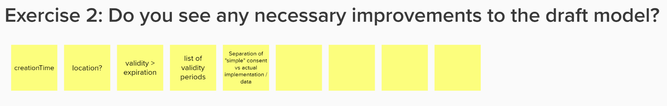

* Location where consent has been given is different to where it is applicable to. Important to clarify this attribute. And important to understand the use of it.
* Time: moment of creation could be better to be called CreationTime
* For audit purpose: could be good to create something like AuditTrail with time and location in it combined.

Someone should be able to extend his consent if requested for. But therefore it must be able to have a clear overview of what has already been given consent to. So, this should be documented carefully and easy to retrieve.

Another challenge goes with grouping of the data. Single resource will not be enough. Footprints or trees to give something more meaningful to the users.

**About the metadata:**

* Limit complexity of the consent: in data exchange you need to have the necessary metadata for a company to have very trusted automation. You need to define certain trust levels with metadata in the data exchange.
* Separate the metadata and the categorisation of the content. A request of consent should be simple and give enough information for the consent giver to trust what he gives consent to at the same time.
* It could be a solution to hook up with a concise and an expended presentation to choose which one will be shown to the agent.

Processing & purpose: GConsent has given recommendation on how to and when data is allowed to be used. So, we need to put together constraint on the use of the data.

### Exercise 4: Which attributes do we want to capture for each class?

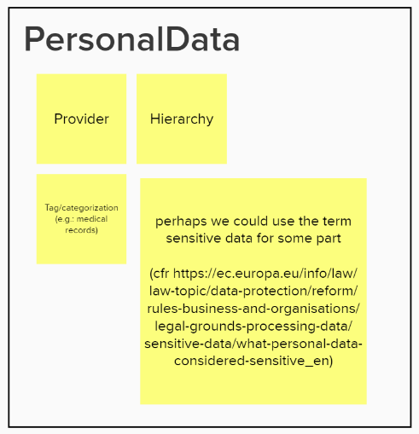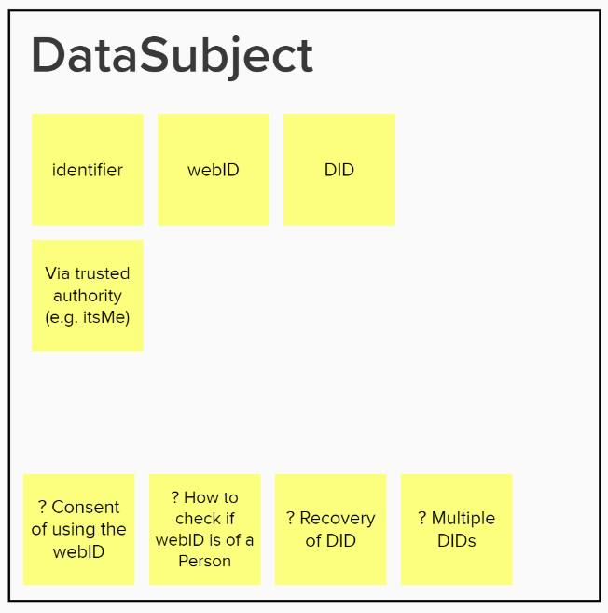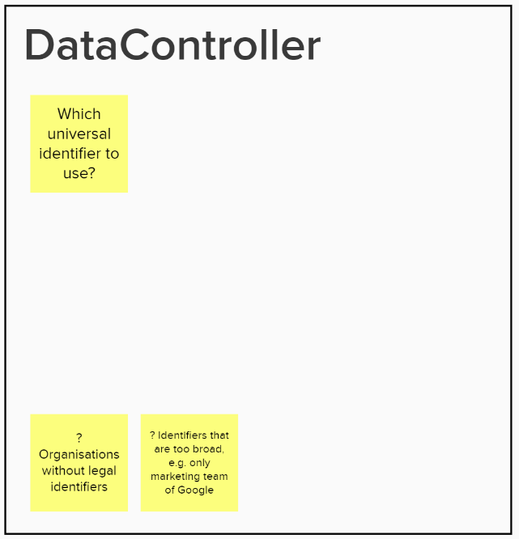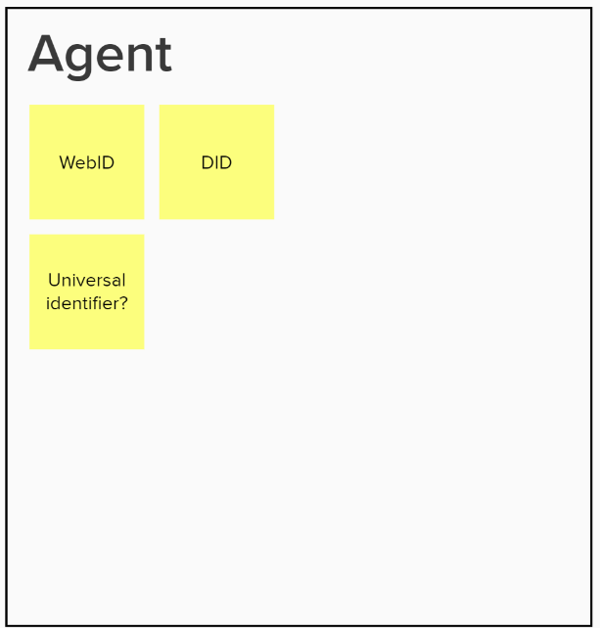

**Personal Data:**

Important to keep in mind what is considered as sensitive data. In GConsent they have defined this, with sensitive data being a subclasse of personal data.

**DataSubject & Agent:**

* Identifier: national register number of Belgium and name is not enough. Looking at webID’s to solve it at this moment. Decentralised ID (DID) is also an option.
* Identifiers are considered as personal information, so you need to have consent to use it.
* Can de webID always be linked to the person and be valid? Not all identifiers go via itsme.
* Sometime organisations don’t have legal identifiers. On the other hand, the content from an identifier can sometimes be too broad.

### Exercise 3: Which use cases do you want to check on this draft model?

The goal of this exercise is to assemble use cases to work on for the next workshop. The input will be assessed before the next workshop.

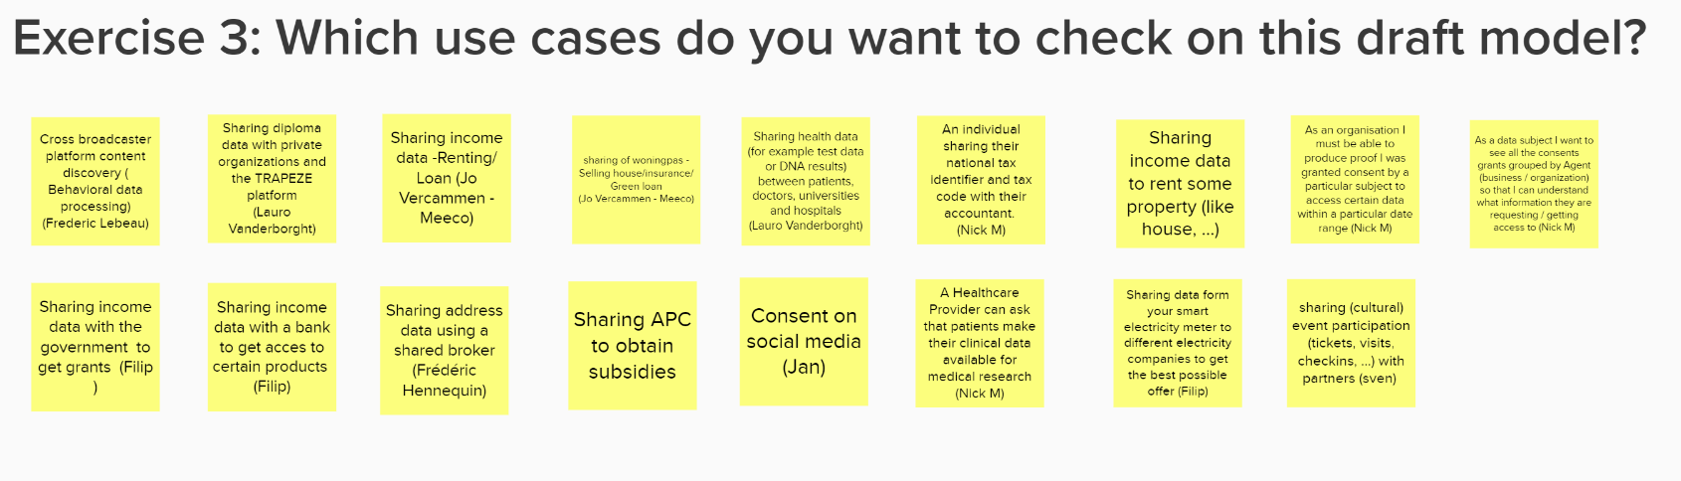

## Part 7: Q&A and next steps

To close the workshop, an overview was given of the next steps in the coming months:

* Process the input from the brainstorm exercise
* Circulate the main findings of this workshop
* Further research and prepare the first thematic workshop
* Capture further input through GitHub

If you would like to participate in one of the following thematic workshops, you can find an overview of the workshops and register via the link below. The next thematic workshop will take place on 21/10/’21 at 13h via Microsoft Teams. The link will be sent to the participants after registration.

<https://overheid.vlaanderen.be/opleiding/oslo-trapeze>

In the meantime, if you have any questions or notice a problem, you can always open an issue on Github or send an e-mail to the e-mail addresses below:

* dimitri.schepers@vlaanderen.be
* michael.geamanu@pwc.com